CHEMICAL ENGINEERING TRANSACTIONS  VOL. 93, 2022 | A publication of
The Italian Association
of Chemical Engineering
Online at www.cetjournal.it

Guest Editors: Marco Bravi, Alberto Brucato, Antonio Marzocchella
Copyright © 2022, AIDIC Servizi S.r.l.
ISBN 978-88-95608-91-4; ISSN 2283-9216

Membrane-Less Bioelectrochemical Reactor for the Treatment of Groundwater Contaminated by Toluene and Trichloroethene
Tucci Matteo, De Laurentiis Camilla, Resitano Marco, Cruz Viggi Carolina, Aulenta Federico*
Water Research Institute (IRSA), National Research Council (CNR), 00015 Monterotondo (RM), Italy
federico.aulenta@irsa.cnr.it

To address the ever-growing environmental problem of groundwater contamination, microbial electrochemical technologies (METs) are being studied as promising substitutes for traditional remediation techniques. Among their many advantages, they possess the capability of providing a virtually inexhaustible electron acceptor (or donor) directly in the aquifer without addition of air, oxygen or other chemicals. In this way, they can promote microbially-driven oxidation and/or reduction of contaminants in-situ, in a more sustainable and cost-effective way.
In this work, a tubular membrane-less bioelectrochemical reactor known as the “bioelectric well” was tested at the laboratory-scale for the simultaneous removal of toluene and trichloroethene (TCE), two ubiquitous and harmful groundwater pollutants. The reactor housed a cylindrical graphite anode and a concentric stainless-steel mesh cathode, which were kept physically separated by a polyethylene mesh, which still ensured hydraulic connection between the electrodes. The anode potential was set at +0.2 V vs. the standard hydrogen electrode (SHE) by means of a potentiostat. The reactor was packed with sand in order to favor the retention of slow-growing anaerobic dechlorinating bacteria. Throughout the study, the reactor was operated in continuous-flow mode (average hydraulic retention time 12 hours), and was fed with artificial groundwater spiked with toluene and TCE.
The performance of the system was evaluated primarily in terms of the electric current generation, toluene oxidation, TCE removal, reductive dechlorination (RD) products formation, and coulombic efficiency. When the system was polarized, a steady increase in the removal of contaminants was observed, together with an increase in the formation of RD products and methane. At the end of the polarized run, the removal rates of toluene and TCE were as high as 0.76 ± 0.23 and 0.35 ± 0.05 µmol L⁻¹ d⁻¹, corresponding to 38% and 89% of the contaminant load present in the influent for toluene and TCE, respectively. Overall, the obtained results convincingly demonstrate that anodic and cathodic processes can be simultaneously exploited within an ad hoc designed bioelectrochemical reactor for the treatment of problematic groundwater containing a mixture of oxidizable and reducible contaminants.

  - Introduction
Chlorinated aliphatic hydrocarbons (CAH) and petroleum hydrocarbons (PH) are often found in soil and groundwater due to underground tanks leakage, accidental spills, and improper industrial practices (Guo et al., 2021). Because of their significant toxicity and recalcitrance, these compounds pose critical risks to human health and the environment (Lhotský et al., 2017).
Bioremediation is deemed to be an effective strategy for the clean-up of contaminated sites (Sadañoski et al., 2020). It is based on the modification of environmental conditions like the redox potential, and/or the subsurface injection of electron donors or acceptors (Davoodi et al., 2020) to enhance the natural capability of microorganisms to metabolize contaminants and to transform them into harmless or less toxic end-products.
However, PH and CAH have very different chemical properties, thus different bioremediation treatments need to be applied. The main limiting factor for PHs oxidation in subsurface environments is usually the lack of electron acceptors, which needs to be artificially provided usually in the form of oxygen, nitrate or sulfate (Ossai et al., 2020). On the other hand, CAH are preferably biodegraded via a reductive pathway (i.e. reductive dechlorination, or RD), hence an electron donor (e.g., H₂ or H₂–releasing fermentable substrates) can be supplied to enhance the metabolism of the so-called organohalide-respiring bacteria (OHRB) (Atashgahi et al., 2016).
For this reason, when PH and CAH are both present in a contaminated site, a combined strategy needs to be implemented. Nevertheless, to avoid competitive reactions which may hinder the rate and efficiency of the bioremediation process, electron acceptors (for PH oxidation) and electron donors (for CAH reductive dechlorination) should be delivered separately, thus complicating design and implementation of the bioremediation process.
In principle, PH could provide themselves the reducing power needed to drive the RD of CAH, but the majority of OHRB can use exclusively H₂ as electron donor (Löffler et al., 2013). For this reason, the syntrophic cooperation among PH- and CAH-degrading microorganisms both in lab-scale and on-field biotreatments has rarely been reported in literature so far.
In the last decades, microbial electrochemical technologies (METs) have been increasingly studied for the treatment of contaminated soils and groundwater (Wang et al., 2015). METs rely on the capability of electro-active microorganisms to oxidize or reduce pollutants using a solid-state electrode as virtually inexhaustible electron acceptor or donor. METs have already been proven to accelerate the bio-oxidation of PH such as benzene, toluene, xylenes, and ethyl-benzene (i.e. BTEX) (Palma et al., 2018), as well as enhance the RD of various CAH such as perchloroethene (PCE), trichloroethene (TCE), and 1,2,-dichloroethane (1,2-DCA) (Lai et al., 2017). However, the simultaneous removal of PH and CAH utilizing both the anodic and the cathodic reaction in a single MET has been rarely attempted.
In this work, a cylindrical MET known as “bioelectric well” (Palma et al., 2018), which is specifically designed for in-situ treatment of contaminated groundwater, is tested for the bioremediation of a mixture of toluene (as model PH) and TCE (as model CAH) for the first time. The obtained results proved that the current generated from the oxidation of toluene at the anode is the driving force that sustains the RD of TCE to less-chlorinated or eventually non-chlorinated end-products via electrochemical production of H₂ at the cathode.

  - Materials and methods
The bioelectric well consists of a glass cylinder (volume: 250 mL) containing an anode composed of 8 adjacent graphite rods (rod dimensions: 30 x 0.6 cm; purity: 99.995%; Merck, Germany) and a concentric stainless-steel mesh cathode (dimensions: 3 x 30 cm; type 304, Alpha Aesar, USA) (Figure 1A). The two electrodes are physically separated by a polyethylene mesh (Figure 1B), which still allows hydraulic connection between the anodic and cathodic region. The anode potential was imposed by means of an potentiostat (IVIUMnSTAT, IVIUM Technologies, The Netherlands) at 0.2 V vs. SHE, and an Ag/AgCl electrode (+198 mV vs. SHE) was used as reference. The reactor column was packed with river sand in order to increase the retention of the slow-growing dehalogenating microorganisms.
The reactor was inoculated with 0.2 L of contaminated groundwater obtained from a petrochemical site in Italy and with 50 mL of a dechlorinating microbial culture enriched with Dehalococcoides mccartyi (Tucci et al., 2021).
During operations, the reactor was continuously fed with synthetic groundwater prepared as reported by Tucci et al. (2021) and spiked with toluene and TCE (Merck, Germany) at concentrations ranging from 0.1 to 2.0 mmol L⁻¹ and from 0.04 to 0.24 respectively. The synthetic groundwater was stored in a collapsible Tedlar® bag (volume: 5 L) and pumped through a port situated at the bottom of the cylinder (flow rate: 0.75 L/d, HRT: 9.3 h) by means of a peristaltic pump (120S, Watson Marlow, UK). The treated effluent was discharged from a port at the upper end of the cylinder (Figure 1).
All tubings were made of Viton® (Merck, Germany) to limit volatilization losses and organic contaminant adsorption as much as possible.
The inlet and the outlet of the bioelectrochemical reactor were provided with flow-through, continuously stirred, sampling cells (volume: 25 mL). The whole study was conducted at room temperature (i.e., 24 ± 3°C).
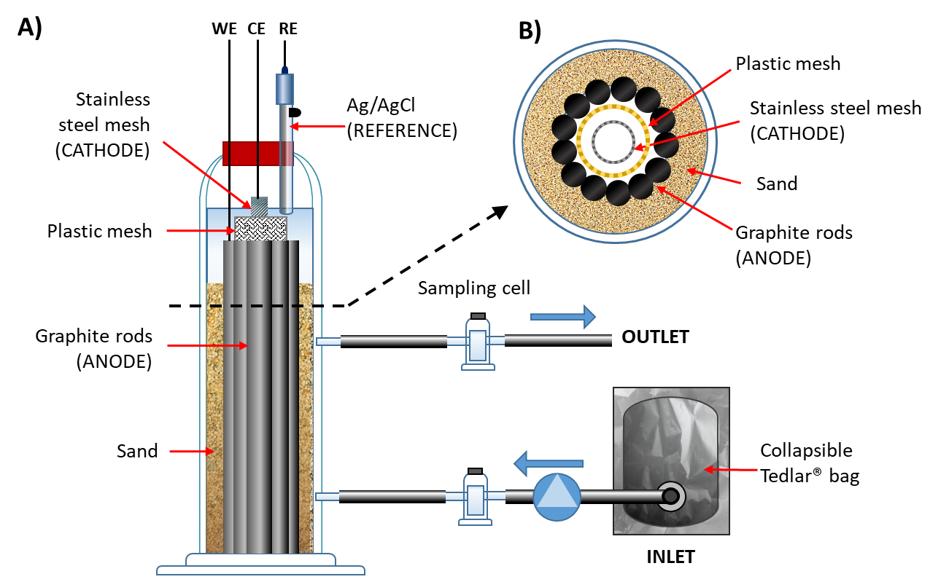
Figure 1: A) Schematic representation of the bioelectric well configuration used for the experiments; B) cross-section of the reactor.

    - Gas analyses
Throughout the study, the headspace of the inlet and outlet sampling cells was analyzed (twice a day) for determination of O₂, H₂ and CH₄ using a gas-chromatograph (Agilent 8860, GC system, USA) equipped with a thermal conductivity detector (TCD) and for determination of toluene, TCE, cis-dichloroethene (cis-DCE), vinyl chloride (VC) and ethylene (ETH), using a gas-chromatograph (Agilent 8860, GC system, USA) equipped with a flame ionization detector (FID). The obtained gas-phase concentrations were converted into liquid-phase concentrations using tabulated Henry’s Law constants (Sander, 2015). The detailed GC methods, together with calibration ranges and LOD are reported elsewhere (Tucci et al., 2021).

    - Calculations
The removal rate of both toluene and TCE q (μmol L⁻¹ d⁻¹) were calculated using the following equation:
$$q=\frac{C_{in}-C_{out}}{V_{r}} Q$$ | (1)
where C_{in} and C_{out} (μmol L⁻¹ d⁻¹) are the liquid phase concentrations of toluene or TCE measured in the influent and the effluent respectively, V_{r} (L) is the volume of the reactor and Q (L d⁻¹) is the inlet flow rate.

Similarly, the formation rate of the reductive dechlorination products q_{RD} (μeq L⁻¹ d⁻¹) generated from TCE was calculated as follows:
$$q_{RD}=\frac{C_{out,DCE} ×2 +{ C}_{out,VC} ×4 + C_{out,ETH }×6}{V_{r}} Q$$ | (2)
where C_{out},_{DCE}, C_{out},_{VC}, and C_{out},_{DCE} (μmol L⁻¹ d⁻¹) are the measured concentrations of DCE, VC and ethene in the outlet, and 2, 4, or 6 are the number of moles of electrons required for the formation of 1 mol of each of these compounds from TCE, respectively.

The toluene or TCE removal η% was calculated using the following equation:
${}_{\%}=\frac{C_{in}-C_{out}}{C_{in}}×100$ | (3)
The columbic efficiency (CE) was calculated as ratio between the charge (i.e. integral of the electric current over time) and the amount of electrons deriving from the compete oxidation of removed toluene per day, as expressed in the following equation:
$$CE(\%)=\frac{\int{i}\left(t\right)×dt ×60×60×24}{\left(∆_{Tol}×f_{Tol}\right)×F} ×100$$ | (4)
where i is the measured current (mA), F is the Faraday’s constant and Δ_{Tol} is the amount of removed toluene (mmol d⁻¹), f_{Tol} represents the number of mmol of electrons released from the complete oxidation of 1 mmol of toluene.

  - Results and Discussion
The reactor was operated for thirty-five days. At the start of the experiment, the system was operated in open circuit (OCP) for seven days, corresponding to nearly 20 HRT, hence a period sufficiently long to properly assess the contribution of abiotic process and of the endogenous metabolism of the inoculum on toluene and TCE removal. Subsequently, the system was switched to polarized mode. In Figure 2A is depicted the trend of the current measured throughout the experiment. After an initial start-up phase, the produced current reached a quite stable level, with an average of 2.5 mA. As soon as the anode was polarized, increasing concentrations of toluene were removed in the system (Figure 2B). This indicates that the degradation of toluene is dependent on the bioelectrocatalytic activity of the microorganisms present in the reactor.
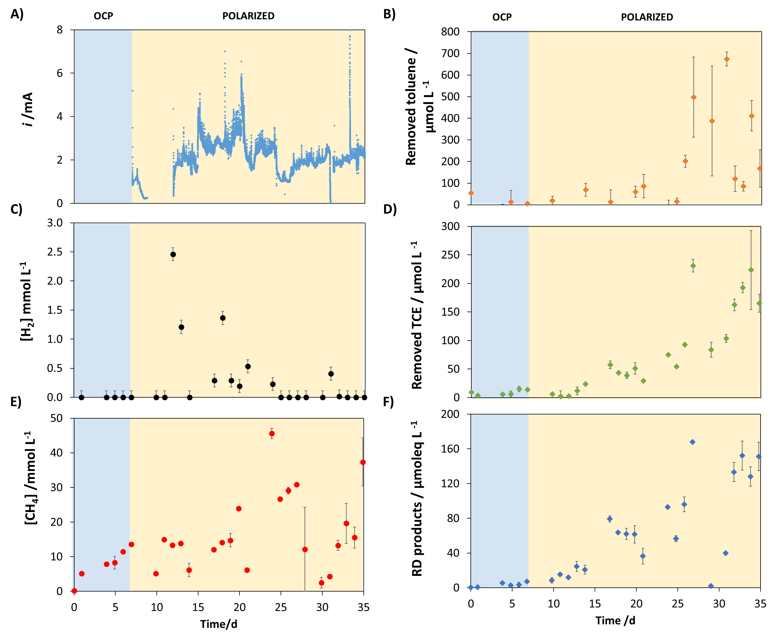
Figure 2: Trends of A) current generation, B) toluene removal, C) hydrogen concentration, D) TCE removal, E) methane production, F) RD products concentration during the whole study, both in OCP and polarized mode.
Figure 2C shows the trend of hydrogen production. A sharp increase of hydrogen concentration could be observed shortly after the reactor was polarized. However, after few days the produced hydrogen was completely consumed, most likely employed as electron source in the metabolic activity of the microbial populations. Indeed, as it can be observed in Figure 2D, the removal of TCE drastically increased when the system was polarized. Therefore, the bioelectric well was able to use the electrons generated by the toluene oxidation to degrade TCE via RD. The production of methane also increased during the course of the experiment (Figure 2E), meaning that a small amount of the hydrogen produced at the cathode was employed by methanogenic microorganisms. As further evidence of the bioelectrochemically-driven TCE degradation, the concentration of reductive dechlorination products was measured. As shown in Figure 2F, the sum of the reductive dehalogenation products (expressed as electron equivalents) follows the same trend of TCE removal, confirming the increase of biocatalytic activity of the dehalogenating bacteria in the polarized run. The analysis also revealed that cis-DCE was the most abundant among the degradation products of TCE, followed by VC and ethylene (Figure 3A).
The removal rates obtained for toluene and TCE at the end of the polarized run were 0.76 ± 0.23 and 0.35 ± 0.05 µmol L⁻¹ d⁻¹, respectively. These values are obtained as average of the values measured in the last 5 days of experimentation (from 30 to 35). With respect to the contaminant load of the influent, the system removed about 38% for toluene and up to 89% of TCE. The obtained results point out the effectiveness of the bioelectric well in removing in a single-stage oxidizable and reducible contaminants, opening for new possibilities in the field of groundwater bioremediation.

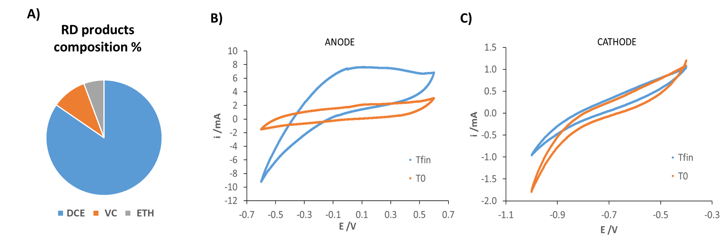
Figure 3: A) Relative abundance of the reductive dechlorination products; Cyclic voltammograms conducted B) on the anode and C) on the cathode at the beginning (T0) and at the end (Tfin) of the experiment (scan rate: 1mV s⁻¹).
The (bio)electrocatalytic activity of the electrodes was also monitored by means of cyclic voltammetry, which were conducted at the beginning and at the end of the experiment. As shown in Figure 3B, the oxidative current measured with the (bio)anode greatly increased since the experiment started, indicating a successful development of an electroactive biofilm. On the other hand, the cyclic voltammograms conducted on the cathode (Figure 3C) indicate a slight loss of reductive current, probably caused by a partial passivation of the stainless-steel mesh over time.

  - Conclusions
This work demonstrated the capability of the «bioelectric well» of simultaneously removing oxidizable (toluene) and reducible (TCE) groundwater contaminants. The results highlighted the impact of the polarization on the contaminant removal, reaching removal rates for toluene and TCE as high as 0.76 ± 0.23 and 0.35 ± 0.05 µmol L⁻¹ d⁻¹ at the end of the polarized run, which corresponded to about 38% and 89% of the total influent load for toluene and TCE, respectively. However, the dechlorination products were dominated by cis-DCE, which indicates an incomplete degradation of TCE. Therefore, future research should address how to optimize the operational parameters of the system in order to complete the reductive dechlorination process all the way to the harmless ethylene. The degradation of toluene can also be improved, as demonstrated by previous works. Moreover, analysis of the microbial communities could give further insights in the interplay of these contaminants in a bioelectrochemical system.

Acknowledgments
This study was supported by the European Union’s Horizon 2020 project ELECTRA (www.electra.site) under grant agreement No. 826244.

References
Atashgahi, S., Lu, Y., Smidt, H., 2016. Overview of Known Organohalide-Respiring Bacteria—Phylogenetic Diversity and Environmental Distribution, in: Organohalide-Respiring Bacteria. Springer Berlin Heidelberg, Berlin, Heidelberg, pp. 63–105. https://doi.org/10.1007/978-3-662-49875-0_5
Davoodi, S.M., Miri, S., Taheran, M., Brar, S.K., Galvez-Cloutier, R., Martel, R., 2020. Bioremediation of Unconventional Oil Contaminated Ecosystems under Natural and Assisted Conditions: A Review. Environ. Sci. Technol. 54, 2054–2067. https://doi.org/10.1021/acs.est.9b00906
Guo, Y., Wen, Z., Zhang, C., Jakada, H., 2021. Contamination characteristics of chlorinated hydrocarbons in a fractured karst aquifer using TMVOC and hydro-chemical techniques. Sci. Total Environ. 794, 148717. https://doi.org/10.1016/j.scitotenv.2021.148717
Lai, A., Aulenta, F., Mingazzini, M., Palumbo, M.T., Papini, M.P., Verdini, R., Majone, M., 2017. Bioelectrochemical approach for reductive and oxidative dechlorination of chlorinated aliphatic hydrocarbons (CAHs). Chemosphere 169. https://doi.org/10.1016/j.chemosphere.2016.11.072
Lhotský, O., Krákorová, E., Linhartová, L., Křesinová, Z., Steinová, J., Dvořák, L., Rodsand, T., Filipová, A., Kroupová, K., Wimmerová, L., Kukačka, J., Cajthaml, T., 2017. Assessment of biodegradation potential at a site contaminated by a mixture of BTEX, chlorinated pollutants and pharmaceuticals using passive sampling methods – Case study. Sci. Total Environ. 607–608, 1451–1465. https://doi.org/10.1016/j.scitotenv.2017.06.193
Löffler, F.E., Yan, J., Ritalahti, K.M., Adrian, L., Edwards, E.A., Konstantinidis, K.T., Müller, J.A., Fullerton, H., Zinder, S.H., Spormann, A.M., 2013. Dehalococcoides mccartyi gen. nov., sp. nov., obligately organohalide-respiring anaerobic bacteria relevant to halogen cycling and bioremediation, belong to a novel bacterial class, Dehalococcoidia classis nov., order Dehalococcoidales ord. nov. and famil. Int. J. Syst. Evol. Microbiol. 63. https://doi.org/10.1099/ijs.0.034926-0
Ossai, I.C., Ahmed, A., Hassan, A., Hamid, F.S., 2020. Remediation of soil and water contaminated with petroleum hydrocarbon: A review. Environ. Technol. Innov. 17, 100526. https://doi.org/10.1016/j.eti.2019.100526
Palma, E., Daghio, M., Franzetti, A., Petrangeli Papini, M., Aulenta, F., 2018. The bioelectric well: a novel approach for in situ treatment of hydrocarbon-contaminated groundwater. Microb. Biotechnol. 11, 112–118. https://doi.org/10.1111/1751-7915.12760
Sadañoski, M.A., Tatarin, A.S., Barchuk, M.L., Gonzalez, M., Pegoraro, C.N., Fonseca, M.I., Levin, L.N., Villalba, L.L., 2020. Evaluation of bioremediation strategies for treating recalcitrant halo-organic pollutants in soil environments. Ecotoxicol. Environ. Saf. 202, 110929. https://doi.org/10.1016/j.ecoenv.2020.110929
Sander, R., 2015. Compilation of Henry’s law constants (version 4.0) for water as solvent. Atmos. Chem. Phys. 15, 4399–4981. https://doi.org/10.5194/acp-15-4399-2015
Tucci, M., Carolina, C.V., Resitano, M., Matturro, B., Crognale, S., Pietrini, I., Rossetti, S., Harnisch, F., Aulenta, F., 2021. Simultaneous removal of hydrocarbons and sulfate from groundwater using a “bioelectric well.” Electrochim. Acta 388, 138636. https://doi.org/10.1016/j.electacta.2021.138636
Wang, H., Luo, H., Fallgren, P.H., Jin, S., Ren, Z.J., 2015. Bioelectrochemical system platform for sustainable environmental remediation and energy generation. Biotechnol. Adv. 33, 317–334. https://doi.org/10.1016/j.biotechadv.2015.04.003

